Name ______________________
Class Period _________________

Character “Iceberg” Analysis: Esperanza

Part I: Illustrations
Draw 2 pictures of symbols that represent Esperanza’s visible character traits on the top surface of the iceberg (traits shown to others). Then, draw 2 pictures of symbols that would best represent her “hidden” or internal character traits underneath the iceberg (traits below the surface).

ESPERANZA
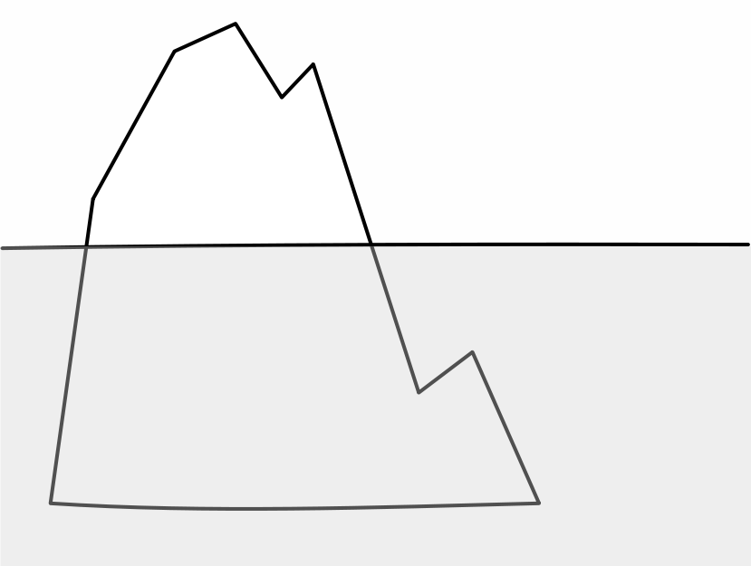

Part II: Explanation and Analysis
“SEEN”
Symbol to represent Esperanza | Explanation of symbol literally | How this symbol connects to the character
Esperanza is like a ____________

Esperanza is like a ____________

“UNSEEN”
Symbol to represent Esperanza | Explanation of the symbol literally | How this symbol connects to the character
Esperanza is like a___________

Esperanza is like a ___________

